15th August 2017

**YOKOHAMA Europe celebrates Anniversary with Micro-site**

As part of its contribution to the Yokohama Rubber Company 100th Anniversary, its regional head office in Europe has launched a micro-site which offers a historical overview of the Japanese Global company.

The microsite has been divided into three timelines which highlight the foundation and early years of the company from 1917 and will carry through to the present day.

Two time periods are now accessible via the Yokohama Europe website and directly on this link:

<http://specials.yokohama-online.com/100-years/>

The third and final phase of the special micro-site will be launched at the end of September with additional interactive features and the opportunity to win prizes.

The micro-site aims to portray some of the milestones of the Japanese Global company throughout its 100 years history and uses interactive features and design which make it both interesting and attractive.

Recognised for its pioneering technology and innovation and catering for a wide range of tyres which include the full range of passenger car tyres, Truck and Bus, Motorsport and OTR tyres. Whether fuel saving with environmental credentials or high-performance tyres, YOKOHAMA Rubber continues with its essential philosophy to contribute to society by creating beneficial products.

Yokohama Rubber was established in Yokohama City, Kanagawa Prefecture, on October 13, 1917.

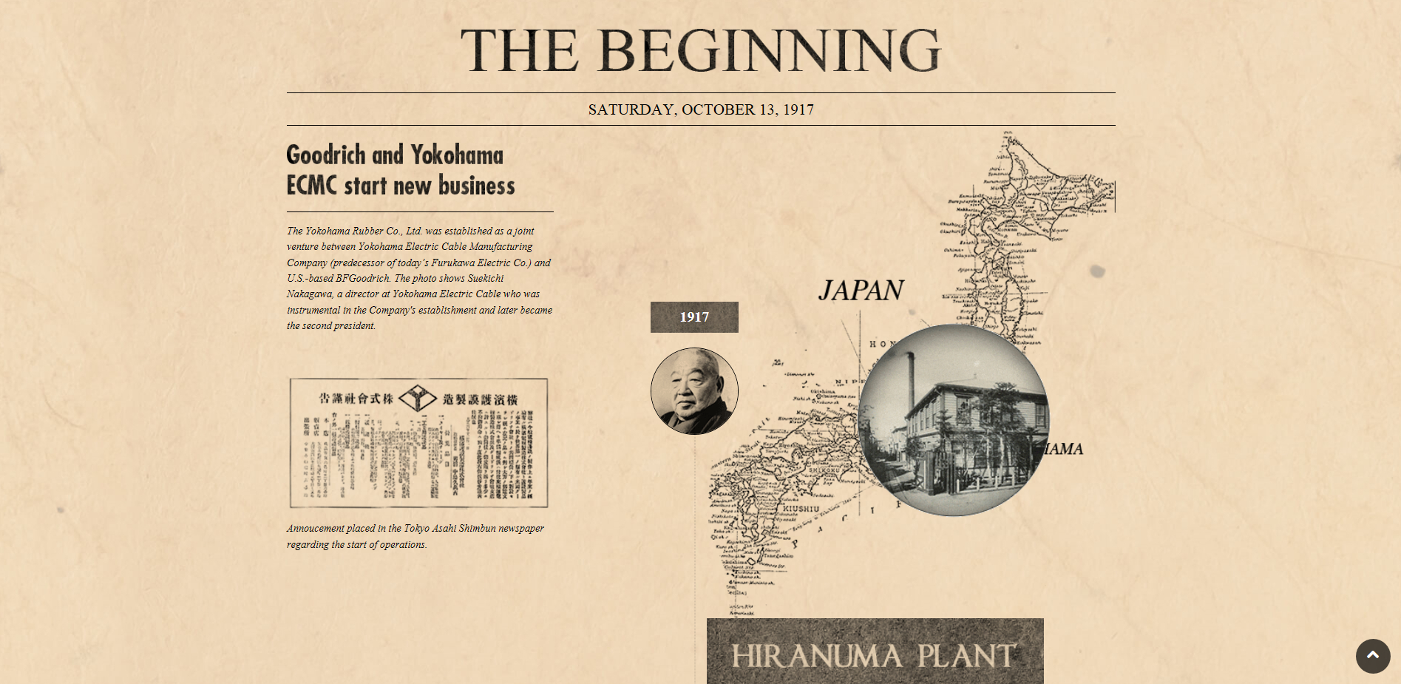

*The Beginning YOKOHAMA Europe Special Anniversary celebration*

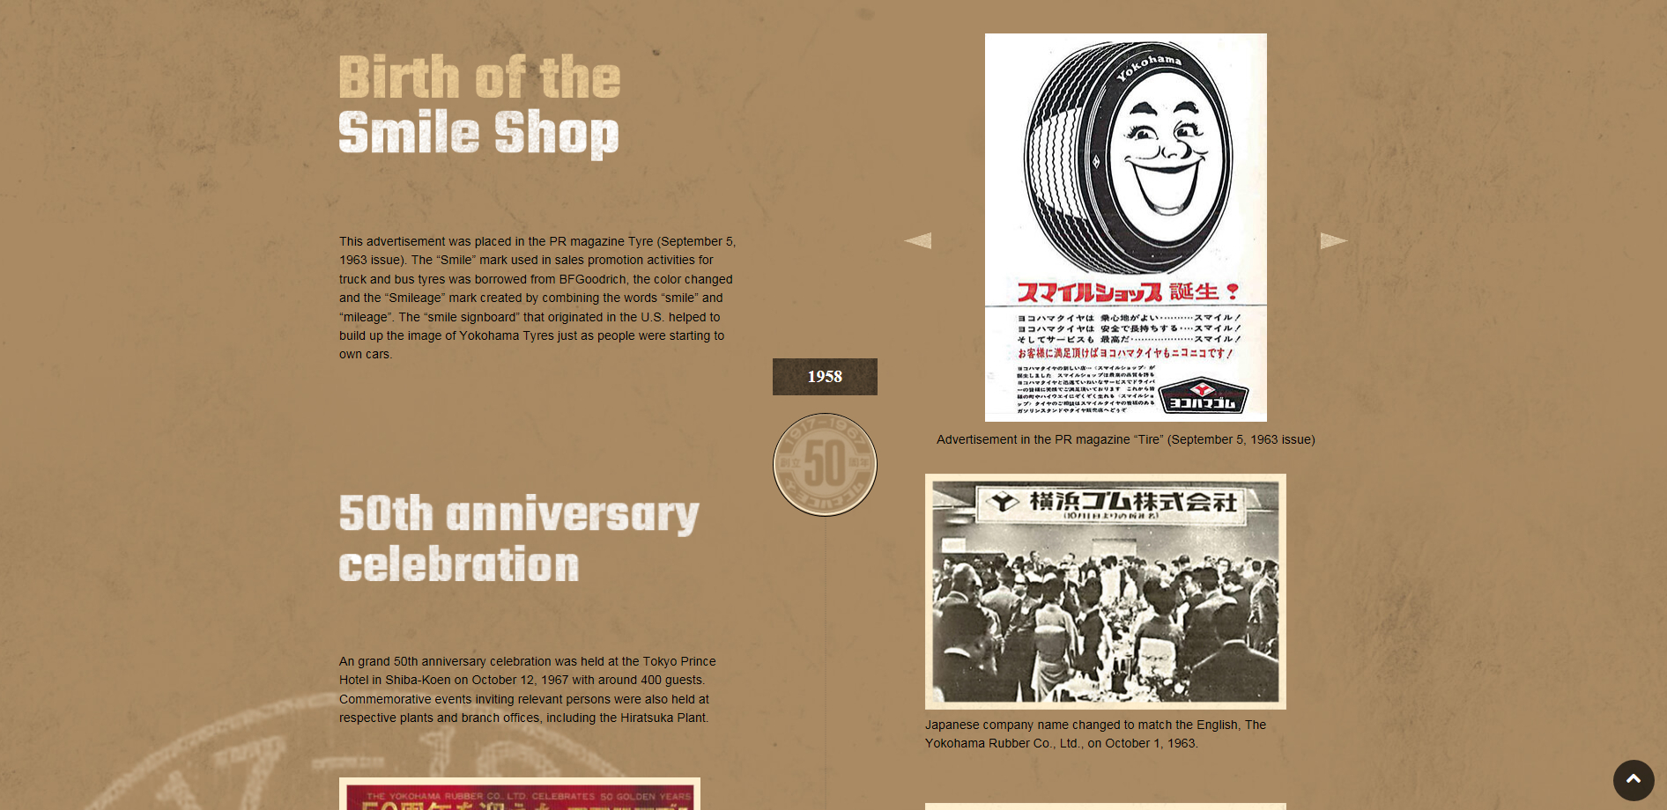

*YOKOHAMA '50s and '60s*



*Motorsports in YOKOHAMA's DNA Special Anniversary micro-site*